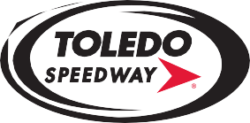
5639 Benore Road-Toledo, OH 43612
419-727-1100 Toledo
734-782-2480 Flat Rock

FLAT ROCK/TOLEDO SPEEDWAY RULES AMENDMENTS (MARCH 11, 2024)

ARCA FACTORY STOCK/ENDURO CARS
Page 45, 1. Dual overhead cam engines are permitted; Add 50 lbs. for this engine. NO turbo engines.
Page 47: Weight: Dual overhead cam engines-2450 lbs. minimum weight.

(The rest of the existing wording in each of these items remains unchanged).

ARCA LATE MODEL SPORTSMAN CARS
Page 42, 16. Weight: Maximum of 60% left side weight for approved crate engines. Built engines up to 360 CID and built engines over 360 CID maximum left side weight is 60%.

(The rest of the existing wording in this item remains unchanged).

Jack Franzil
Chief Inspector

